SECRETARIAT INTERNATIONAL CONFERENCE ON THE GREAT LAKES REGION
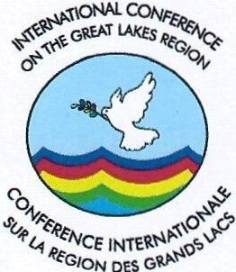

SECRETARIAT CONF};:RENCE INTERNATIONALE SUR LA R};:GION DES GRANDS LACS

MESSAGE FROM AMBASSADOR JOAO SAMUEL CAHOLO ICGLR EXECUTIVE SECRETARY
ON INTERNATIONAL WOMEN'S DAY CELEBRATION
8TH MARCH 2023

On the occasion of International Women's Day 2023, we are happy to join the world in commemorating and celebrating women's achievements and contributions to the peace and security efforts in the great lake region. Women are the central caretakers of families, and everyone is affected when they are excluded from decision making processes because they are strong peace makers and change agents.

This year's theme is: Digit ALL: Innovation and technology for gender equality. This theme is timely and very appropriate in contemporary context when our region is facing various challenges and requiring a common understanding on sustainable development wherein the women have to play a very prominent role. Innovation and technology provide a window for not only e empowerment of women but an opportunity for them to fully attain their aspirations and goals. Women's participation in the digital sphere is therefore not just a matter of gender equality but it is a prerequisite for sustainable development.

Therefore, I would like to make an appeal to our Member States that as we commemorate this day, we take stock of not only what we have achieved but also further create enabling environment for gender equality. This calls for enactment of laws and policies which promote the creation of favourable conditions for women to have easy access to training, equipment and other digital services to empower themselves and contribute to the integral development of their families, communities, nations and regions. At the same time protecting women and the girl child against all forms of cyberbullying, crime, hate speech, sexual harassment and exploitation, as well as child trafficking, which is also becoming increasingly prevalent in the digital world today.

Onour part, we will continue to lobby and advocate for the full implementation ofthe ICGLR Protocol on the Prevention and Suppression of Sexual Violence against Women and Children and domesticate its gend guide policies. We
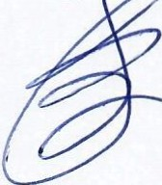

also call upon Member States and all stakeholders to design innovative programmes aimed to promote Gender mainstreaming, women's leadership and economic empowerment for peace and security, as well as social and economic change in the Great Lakes Region.

Done in Bujumbura, 8th March 2023

